East Upper/Lower School

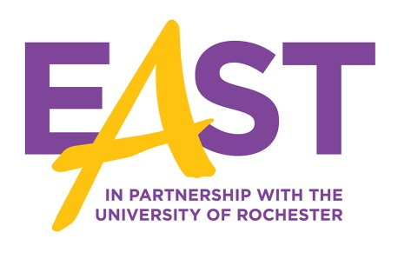

Mr. Militello

Physical Education Teacher

Head Varsity Football Coach

SUNY Brockport (Bachelors) ‘95

USSA (Masters) ‘04

Contact Information:

[michael.militello@rcsdk12.org](mailto:michael.militello@rcsdk12.org)

585-288-3130 x3120

When you live for a strong purpose, then hard work isn’t an option. It’s a necessity.